1. Report out everything about customers who are in Italy or France. Order them by the name of the customer. (16 rows) :

SELECT \* FROM customers where country = 'Italy' or country = 'France' order by customername;

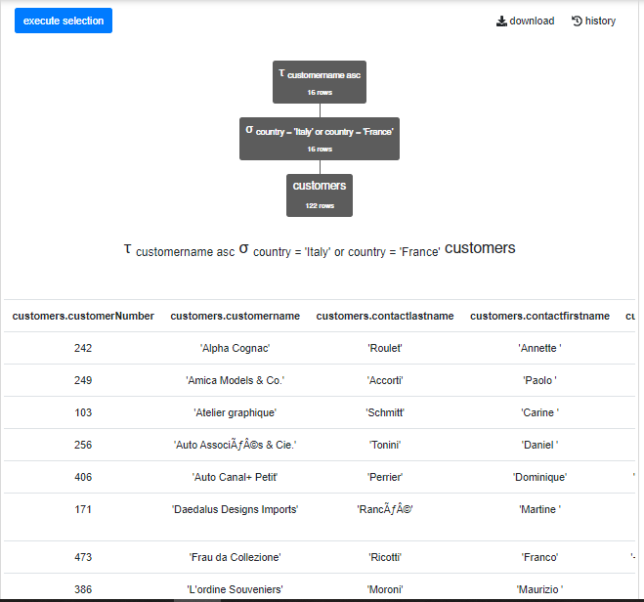τ customername asc σ country = 'Italy' or country = 'France' customers

1. Report out everything about orders placed after January 1st, 2015 and whose status is either ‘On Hold’ or ‘Shipped’. Order by the order date in descending order.

SELECT \* from orders where orderDate > date('2015-01-01') and (status = 'On Hold' or status = 'Shipped') order by orderDate desc;

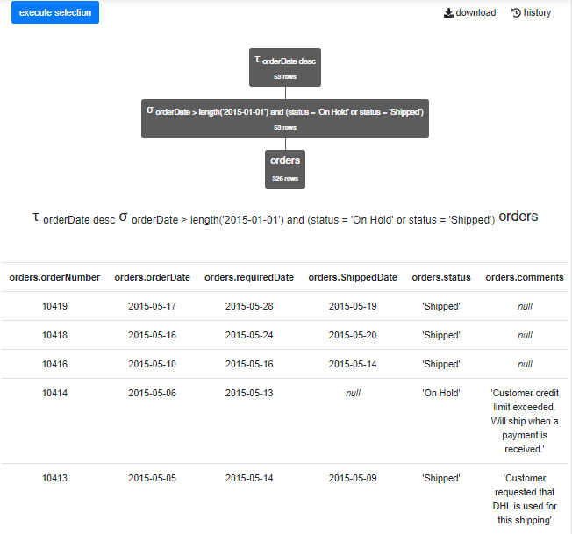τ orderDate desc σ orderDate > date('2015-01-01') and (status = 'On Hold' or status = 'Shipped') orders

1. Provide a list of all employees whose last name starts with “B”. Only report the office code, the employee last name, and their first name. Order them by last name and first name within each office

SELECT productLine, productName from products where upper(productDescription) like '%TWO-TONE%' order by productName;

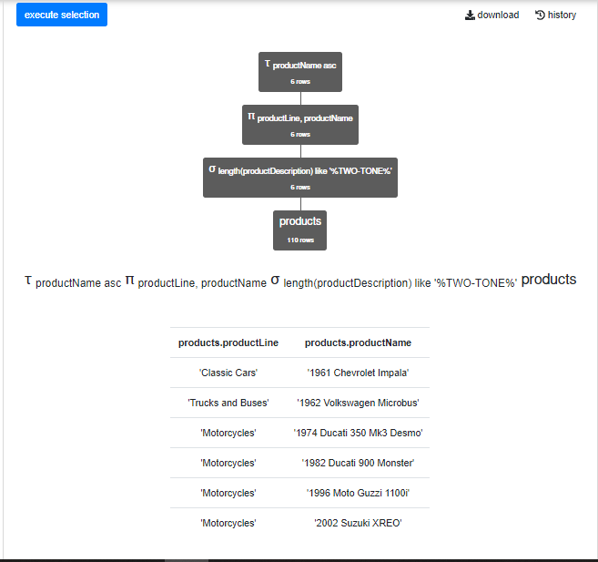τ productName asc π productLine, productName σ upper(productDescription) like '%TWO-TONE%' products

1. Provide a list of all employees whose last name starts with “B”. Only report the office code, the employee last name, and their first name. Order them by last name and first name within each office.

select officeCode, lastName, firstName from Employees where lastName like 'B%' order by lastName, firstName, officeCode;

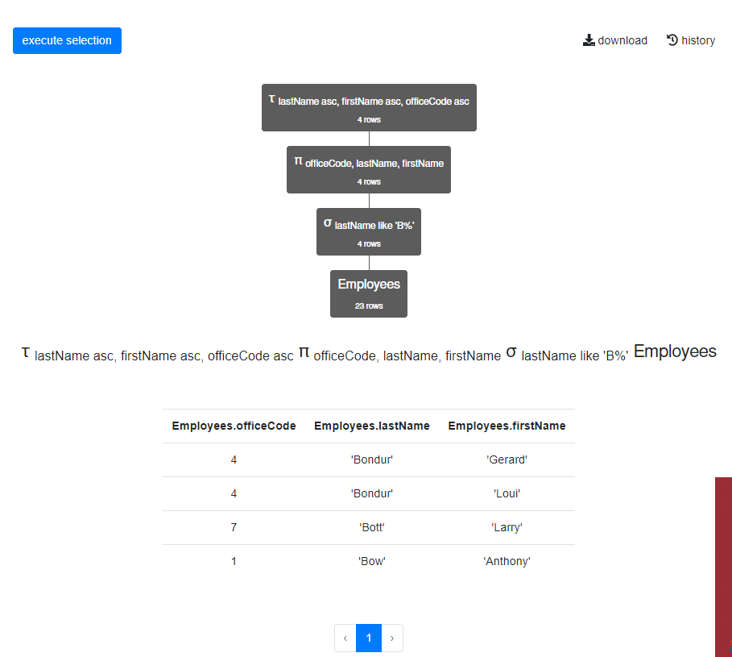

τ lastName asc, firstName asc, officeCode asc π officeCode, lastName, firstName σ lastName like 'B%' Employees

1. List all the types of status that we have, in sorted order. Be sure to only list a given status once. (6 rows)

select distinct status from orders order by status;

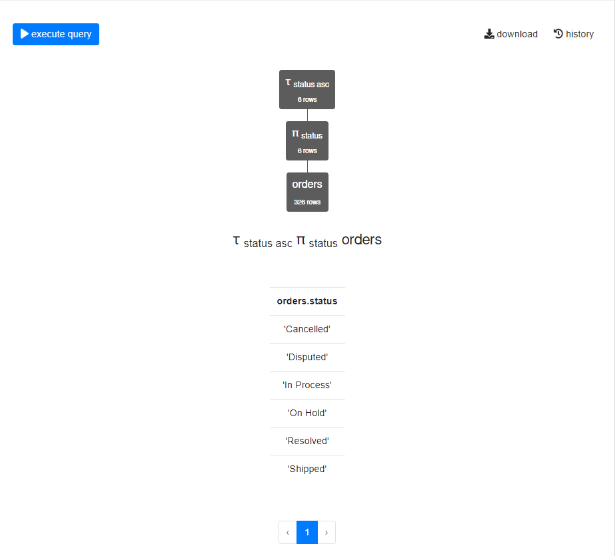τ status asc π status orders

1. List all the columns for all the offices in Paris, France. Note that there are more than one city in the world named Paris. Order by the territory in ascending order, then (secondary sort) on the office code in descending order. (1 row)

select \* from Offices where city = 'Paris' and country = 'France' order by territory asc, officeCode desc;

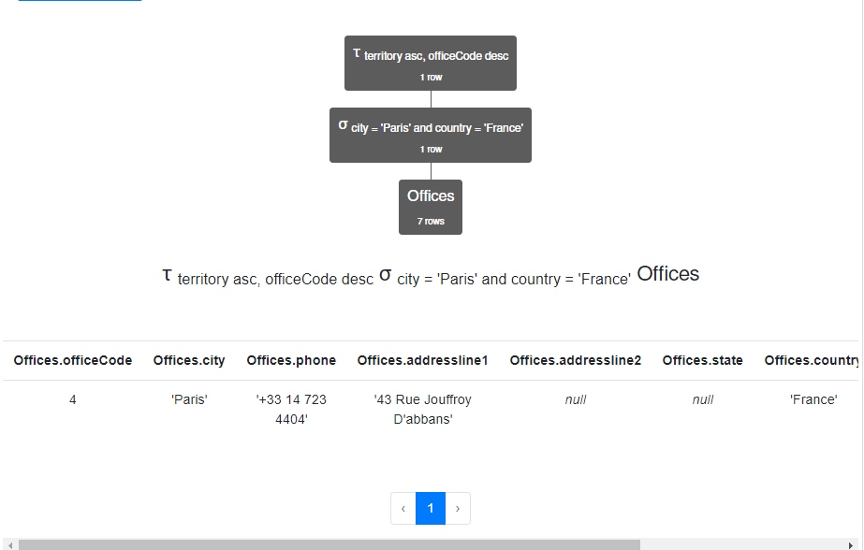

τ territory asc, officeCode desc σ city = 'Paris' and country = 'France' Offices